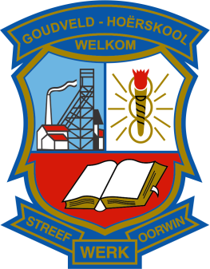
MINUTES OF A MEETING OF THE SDT ON 17.04.2017

- All members are welcomed at the meeting.

- The attendence register is circulated and sighned.

- No apologies have been received.

- The management plan is discussed in detail. A copy of the final document will be circulated to every member of the staff.

- A document about the DSG and its implications is discussed and will be circulated to every member of the staff.

- The school improvement plan (SIP) is discussed and amendmants are made.

- An appeal will be made to the staff that their IQMS files should be updated and be prepared for inspection by the department.

- A date for training on IQMS procedures will be set as soon as possible.

_______________________
Convenor of IQMS
Dr. Willem Stolk

