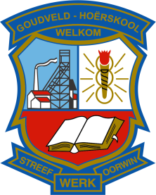
LIST OF SDT MEMBERS

NO. | NAME AND SURNAME | DESIGNATION
1. | Mr Paul Sauer | Principal
2. | Dr Willem Stolk | Deputy Principal
3. | Me Marinda Lombard | PL 2 representative
4. | Me Susan Lombaard | PL 1 representative
5. | Me Leona Jacobs | PL 1 representative

___________________
Convenor of IQMS
Dr. Willem Stolk

